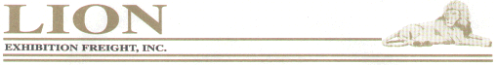
LION Exhibition Freight, Inc
1165 Willingham Dr.
Atlanta, GA 30344
Fax: (404) 305-1185

CREDIT CARD AUTHORIZATION FORM

 |  |  | Show Name:
 |  |  | Show Dates:
I hereby authorize LION Exhibition Freight, Inc. to use the following credit card (as listed below) to pay all customs and freight charges incurred on a Universal Event Services/Showkit.com show in the amount of $______________________
Invoice No:
Type of Credit Card (please circle one): |  |  |  |  |  |  | American Express |  |  | Visa | MasterCard
Credit Card No:
American Express only: 4 digit code printed above embossed account number:
Credit Card Expiration Date:
Signature of Cardholder:
Printed Name of Cardholder as it appears on the card:
Company Name:
Complete billing address of credit card:

*** ALL FIELDS MUST BE COMPLETED ***

